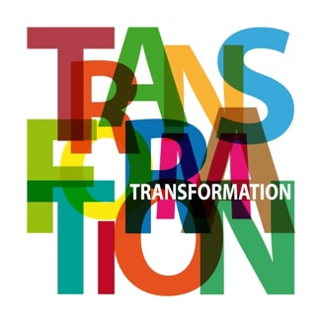
Diocese of Lincoln’s Transformation Fund
Tier 1 Application – up to £500

Please consider the environment before printing this form.
If printing, consider selecting ‘Black & White’ in the colour options.

Part 1: Information

- Applicant Details:

Date of application:
Name of applicant
(church group/ parish / benefice / LMP/DP):
For church applications please select from:
Key Mission Church Local Mission Church Community Church Festival Church
Date of most recent Transformation Fund grant received by the applicant: | (where relevant)

- Contact details

Contact Name:
Contact Address:
Contact Email:

- Project authorisation:
I, the undersigned, confirm that I am suitably authorised to make this application on behalf of the above-named group and have completed this form in good faith.

Signature
(e.g. Parish Priest or Rural Dean)
Print name and role

- Project details

Name of Project
Total Project cost | £
Total funds requested from the Transformation Fund | £

Part 2: Application

- Give a brief overview of your proposed project (up to 100 words)
i.e. What? When? Who? Where? How? Why?

- What are the aims of the project? (up to 100 words)
i.e. Why are you planning this project? How does it relate to your church type? What is the vision? What is the need? What specifically do you want to achieve? How does it relate to your Church Categorisation?

- What will you do to achieve these aims? (up to 100 words)
i.e. What specific activity is planned and when?

- What are the costs of the project? (up to 100 words)
Set out the project budget, including a full “shopping list” of items and their costs.

- How will the project be funded? (up to 100 words)
e.g. Transformation Fund (entirely/part-funded), reserves, giving, other external grant-makers

- Briefly explain how your project achieves at least one of the following diocesan priorities:

 | Diocesan priority areas | How does the project meet this priority? Max 50 words per answer
A | Faithful worship – growth in the number of people worshiping Jesus Christ as Lord and Saviour
B | Confident discipleship – growth in the depth of faith and spirituality, learning to be followers of Jesus and become more like him
C | Joyful service – growth in serving the church and local community.

- Parish Share

Previous year’s Parish Share requested | £
Previous year’s Parish Share paid | £
Current year’s Covenant Pledge commitment | £
Current year’s Covenant Pledge intending to pay | £
Intended Covenant Pledge for next year | £

- Payment

Payments are made via bank transfer. In the event of a successful application, and in order to arrange a direct-debit payment, please advise us of your PCC’s bank details.

Bank Account Name

Sort Code

Account Number

Submission:

Please send your completed application form to:

Transformation.Fund@lincoln.anglican.org

OR

Transformation Fund
Diocese of Lincoln
Edward King House
Minster Yard
Lincoln
Lincolnshire
LN2 1PU

For any questions, please email Transformation.Fund@lincoln.anglican.org

