Frequently Asked Questions
What form of giving is most helpful for the church?
The most helpful way to support St Peter’s is through the Parish Giving Scheme, which is by Direct Debit. Each month your gift will be processed automatically in accordance with your instructions. This saves you time, means that you won’t forget when life is busy and, significantly, it helps the church with both its cash flow and its financial administration.
How do I get started?
Step 1: Please complete the Giving Review Pledge Form and return it in the envelope provided by placing it in the collection at the service on ‘Pledge Sunday’, 16th October, or by posting it to the Giving Secretary.
Step 2: Please then complete the Giving Form in The Parish Giving Scheme information pack, which is a direct debit instruction, reflecting what you have put on your Pledge Form and send it direct to the Parish Giving Scheme office in the addressed envelope provided. This is the church’s preferred way of receiving regular giving. (If you wish to give via Standing Order instead, please ask for a Standing Order form, along with a Gift Aid declaration form if you are a UK taxpayer.)
How much should I give?
In the Old Testament God’s people were required to give at least 10% of their income to His work and most churches around the world encourage Christians to use this as a rule of life. The New Testament does not impose any law – it is a matter of freedom – we can give less or more as an expression of our gratitude to God. Giving should be a priority for our finances and decided on after careful thought and prayer.
What if I set up a direct debit and my circumstances change?
You can change or cancel your direct debit at any time. Therefore, if you receive a pay increase or a bonus, you can increase your direct debit by telephoning, emailing, or writing to the Parish Giving Scheme Office, or by managing your giving online at www.parishgiving.org.uk. Likewise, if you face a period of reduced income, you can cancel or reduce your direct debit in the same way.
I give each week on the collection plate or by Envelope; is that okay?
If you prefer to give in this way, we are happy to receive your offering, but knowing what our regular income is going to be helps us plan our budget and expenditure. Receiving gifts in cash is more costly in time and bank charges than payments direct into the church’s bank account.
Do I have to tell anyone how much I am giving?
No, your contribution should be made prayerfully, between you and God. The details are treated in the strictest of confidence and are only known to the Giving Secretary, the Treasurer and, at year end, by our independent examiner. The Parish Giving Scheme also gives you the option of giving anonymously, if you prefer, so that no one in the Church will know what you give.

Giving review 2022
“All things come from you O Lord”

Gathering around God’s word
Growing more like Jesus
Going out to serve God’s world

Remember this:
Whoever sows sparingly will
also reap sparingly, and whoever sows generously will also reap generously. Each of you should give what you have
decided in your heart to give, not
reluctantly or under compulsion,
for God loves a cheerful giver.

2 Corinthians 9 v 6 & 7
There is so much that we thank God for here at St Peter’s in Eastgate and Carlton. For over 900 years, Eastgate has been a focal point of worship for the parish and the city, a spiritual home to generations. And now on the Carlton Estate too, St Peter’s is a living expression of Christian hope – the hope of God’s love offered to all.
We are very grateful to all who support St Peter’s – generously giving their time, talents and money to make it possible to continue to fulfil our calling from God at this time. We set out here where things stand financially and ask for prayerful reflection on your part.
YOUR SUPPORT WILL HELP ST PETERS GROW, THROUGH
- continuing to offer regular worship, Baptisms, Weddings and Funerals, and those special services which bring the community together such as at Christmas, Easter, Harvest and Remembrance.
- caring for its buildings and grounds so that our spiritual and community life can be developed, now and for future generations.
- working with people of all ages and at all stages, with a special concern for children and young people, providing opportunities to grow in faith and to develop a closer relationship with God.
WHERE DOES YOUR GIVING GO?
Per month
£6,752 ministry and worship (including urgent organ repair)
WHERE DOES YOUR GIVING SIT ON THIS CHART?
£1,641 running costs of the church (including urgent boiler repair)
£ 626 giving to mission – local, national, and international
£1,620 repairs and maintenance over the next five years
£10,639 Total estimated monthly expenditure
DO YOU KNOW WHAT OUR CURRENT INCOME IS?
Per month (adjusted average – this year)
£6,256 planned giving
£1,502 tax recovered through Gift Aid
£ 85 fees charged for weddings and funerals
£ 584 cash offerings & donations (incl. envelope giving)
£ 996 miscellaneous income (incl. fundraising and room hire)
£9,423 Total average monthly income

= £1,216 per month shortfall – currently funded from reserves
which, at this rate, will disappear very quickly.
Looking ahead, additional income will be needed for
- proposed recruitment of a part-time administrator
- additional paid ministry team members (e.g. Children & Youth work)
- Resourcing new partnerships with churches in Lincoln
- Government and CofE ‘net zero’ targets (major heating changes)
- Increased giving = increased mission giving (local, UK and o/seas)

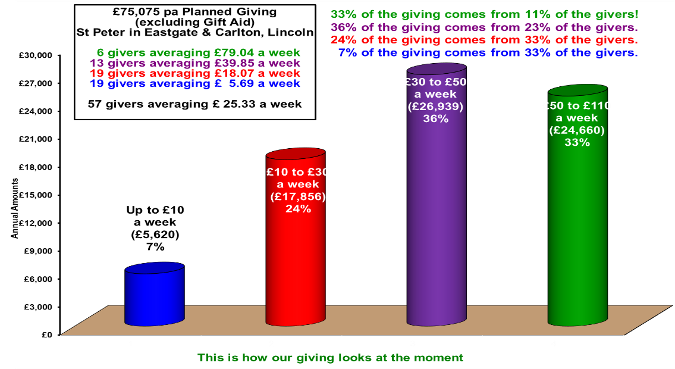

Here’s how we might rise to the challenge to meet the shortfall:

If this many people | Were to increase their monthly giving by | The monthly benefit to St Peter’s would be this
6 | £40.00 (or £10.00/week) | £240.00
12 | £30.00 (or £7.50/week) | £360.00
20 | £20.00 (or £5.00/week) | £400.00
14 | £10.00 (or £2.50/week) | £140.00
15 | £5.00 (or £1.25/week) | £75.00
Total increased monthly giving |  | £1,215.00

